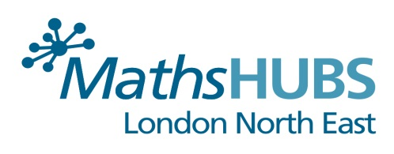 Course Booking Form
Please return this completed document to: admin@lneastmathshub.org.uk
Course Title: | Developing Deep Mathematical Learning in Early Years  (Language in Early Years)
Course Dates: | Day 1: 22nd February 2018  Day 2: 19th April 2018  Day 3: 19th June 2018
Number of Delegates:
Delegate’s Name(s):
Special parking requirements:
(i.e. Blue badge holder)
Special Dietary requirements:
Delegate’s school:
School address:
School telephone number:
Delegate’s email address:
Name of School Finance Officer/
(person who processes invoices)
School Finance Officer’s email address:
All fields are mandatory and bookings cannot be made until we have all the relevant information. Thank you.

